SQL Database Project: Hospital Management Patients, Appointments and Prescriptions Database
Synthetic hospital database (SQLite) | Data Science | Individual report | Noor Ul Huda | 25037630
1. Overview
The data is for an imaginary hospital: 10 departments, 60 doctors, 1,500 patients, 5,000 appointments, and the diagnoses, prescriptions and hospital admissions that follow from them. It has 9 related tables, 57 columns and 16,513 rows, plus three views. Four tables exceed the 1,000-row requirement: appointment_diagnoses (5,430), appointments (5,000), prescriptions (3,936) and patients (1,500). All four scales of measurement are covered (Section 3). The database is a SQLite file named hospital_mansgement_system.db of about 1.2 MB, built by the SQL script hospital_mansgement_system_script.sql.
2. How the data was generated
The data was created by one SQL script (Section 6) that runs directly in SQLite, with no other language and no external data. It drops and recreates every table, inserts the fixed reference data, builds temporary lookup and staging tables, fills the main tables with SQLite's random() function (SQLite, n.d.b), and then drops all temporary tables so that only the final tables, indexes and views remain. All departments, doctors and patients are fictional; the real-world knowledge used is general: the names of common hospital departments, ICD-style diagnosis codes, everyday medicines, UK city sizes and approximate UK blood group frequencies. Tables are created and filled in dependency order, so each foreign key refers to an existing row. random() cannot be seeded, so running the script again builds a database with the same structure and rules but different values; the supplied .db file is the output of one run, and all counts in this report come from it.
Departments, diagnoses and medications. The 10 departments (Cardiology, Neurology, Orthopaedics, Paediatrics, Emergency Medicine, General Medicine, Dermatology, Oncology, Respiratory Medicine and Psychiatry) each have a main ward and a bed capacity. There are 40 diagnoses and 40 medications, four per department, typed in as reference data; each diagnosis has an ICD-style code and a severity, and the medication in the same position is its usual treatment. Doctors (60). Six per department, with a seniority level (23 junior, 16 registrar, 15 consultant, 6 senior consultant). Senior doctors were hired earlier (2007-09-21 to 2025-07-14) and charge higher consultation fees (£56 to £226).
Patients (1,500). Names are drawn from lists of 30 first and 30 last names. About 15% are children, 50% adults aged 16 to 59 and 35% aged 60 or over (245 patients are under 16 and 517 are 60 or older at the end of the study), because hospitals see many older patients. Blood group follows UK frequencies, patients live in 12 UK cities (London 22%), and insurance is 1,230 NHS, 210 private insurance and 60 self-pay. Height depends on age and gender, and weight is calculated from a bell-shaped body mass index so that the two stay plausible. Registration dates fall between January 2018 and October 2026 and never before birth.
Appointments (5,000). Each visit is for a patient (chosen with a mild skew so some patients visit more often), goes to a department that suits the patient's age (children see Paediatrics, adults never do; emergencies go to Emergency Medicine) and to one of that department's six doctors. Dates run from 2018-07-03 to 2026-10-30 and are never before the patient registered or the doctor was hired. Types are check-up, follow-up, emergency, referral and procedure, and triage levels are Low to Critical (more severe for emergencies). 4,099 visits are completed, 494 cancelled and 407 no-shows; only completed visits have a waiting time, a duration and a satisfaction score. Urgent cases wait less, durations depend on the type, 1,234 completed visits have no survey reply (about 30%), and long waits push scores down (average 3.58 for waits up to 30 minutes, 3.15 for 31 to 60 and 2.61 over 60 minutes).
Diagnoses, prescriptions and admissions. Each completed visit gets one to three diagnoses (5,430 rows): the first is from the doctor's own department, with common conditions more often, and extra ones are same-department conditions, a deliberate partner condition (hypertension with diabetes, heart disease with high cholesterol, heart failure with COPD, depression with anxiety) or any diagnosis; for example 72 visits record both hypertension and type 2 diabetes, giving association analysis something to find. About 75% of diagnoses lead to a prescription (3,936 rows), usually the diagnosis's own medication, with a quantity of 1 to 3 packs, a duration of 7 to 56 days and a frequency. Only completed High or Critical visits can lead to an admission (497); Critical cases may go to intensive care and stay longer (1 to 17 days, average 6.5), and most patients go home. Validation. The integrity check returns ok and the foreign-key check finds 0 violations; no visit is dated before registration (0) or hire (0), no cancelled visit has waiting-time, duration or score data (0), and no discharge is before its admission (0).
3. Database schema
The schema has 9 tables and 10 foreign keys (Figure 1). Departments are the hub: doctors, diagnoses and medications each belong to one. Appointments link a patient to a doctor; admissions, appointment_diagnoses and prescriptions all hang off an appointment. appointment_diagnoses and prescriptions resolve many-to-many relationships with compound keys, and admissions is 0-or-1 per appointment through a UNIQUE foreign key. Three views calculate values instead of storing them: patient_ages, admission_stays and appointment_bills. The four scales of measurement covered are listed in Table 1. Dates are ISO-8601 text.
Table 1: Measurement scales covered
Scale | Columns
Nominal | first_name, last_name, gender, blood_group, city, insurance_type, department_name, main_ward, icd_code, diagnosis_name, medication_name, drug_class, appointment_type, status, ward, discharge_destination, frequency, is_primary
Ordinal | seniority_level (Junior Doctor < Registrar < Consultant < Senior Consultant), severity_level (Mild < Moderate < Severe), triage_level (Low < Medium < High < Critical), satisfaction_score (1 to 5)
Interval | date_of_birth, registration_date, hire_date, appointment_date, admission_date, discharge_date (ISO-8601 text; zero is arbitrary)
Ratio | height_cm, weight_kg, bed_capacity, consultation_fee, unit_cost, wait_minutes, duration_minutes, quantity, duration_days; view columns age_years, length_of_stay_days, total_bill

Figure 1: Entity relationship diagram: 9 tables, 57 columns, compound keys marked.
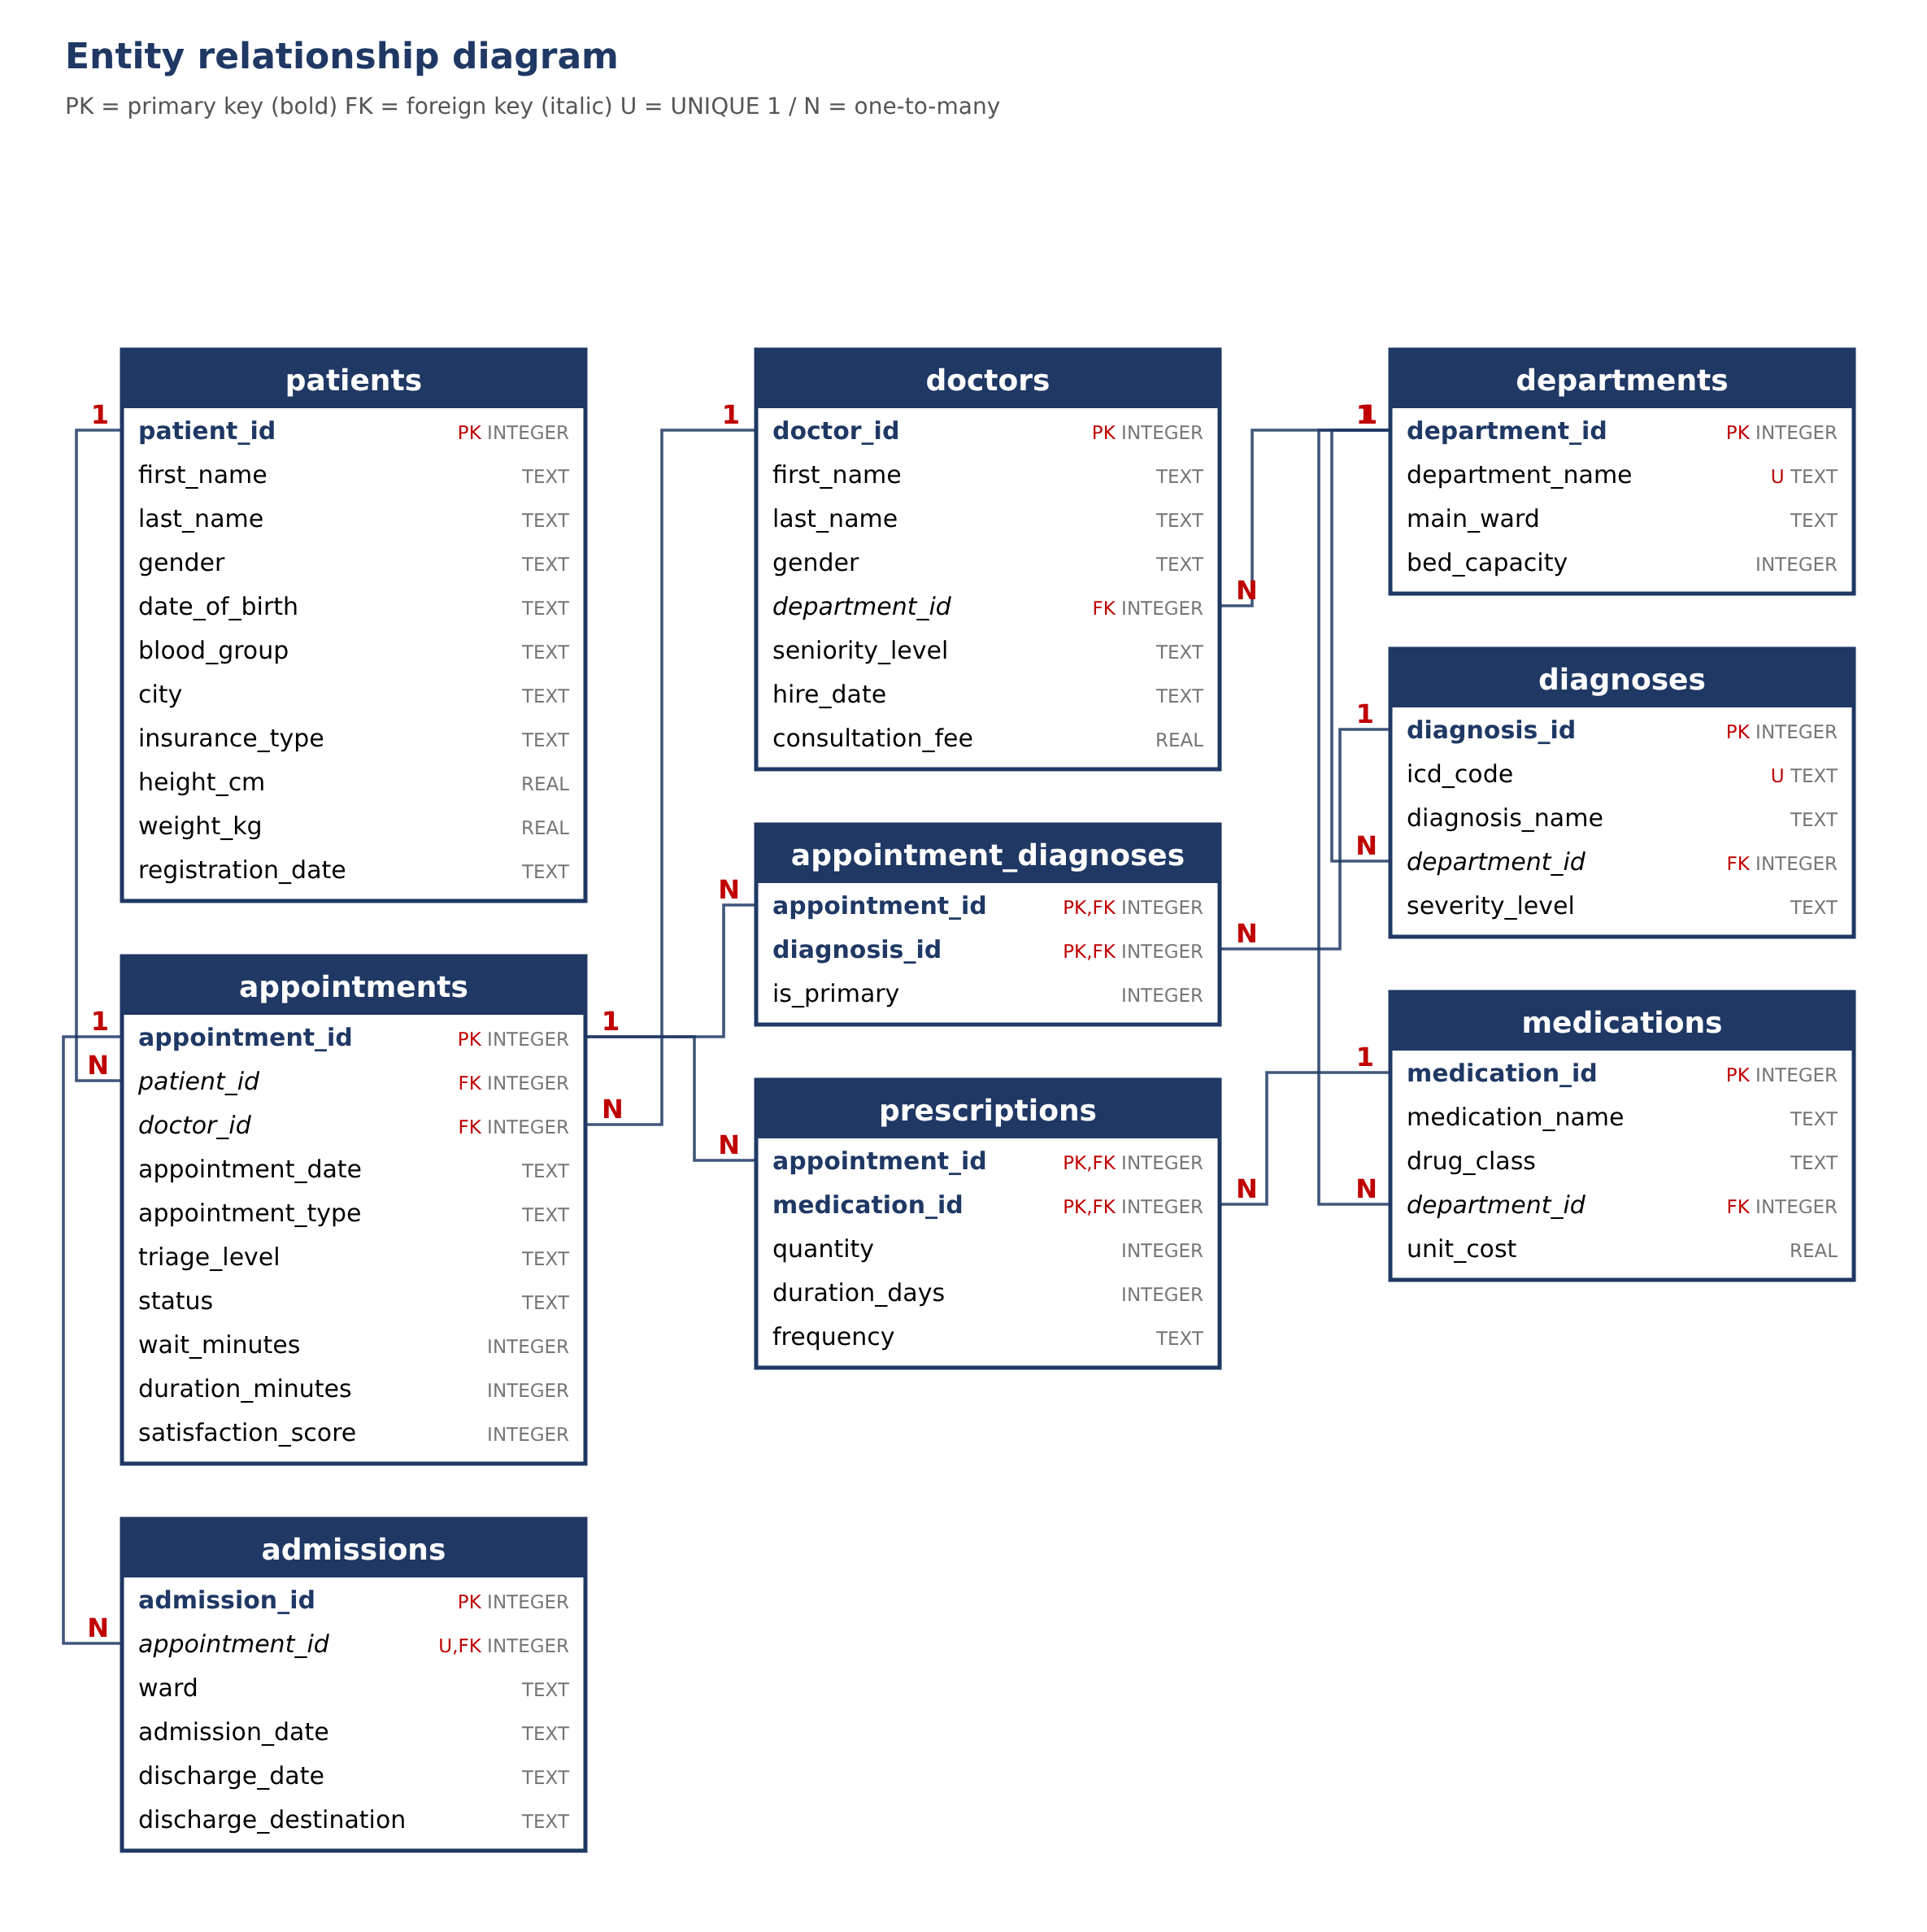
4. Justification for separate tables and constraints
Table 2: Tables, rows and reasons
Table | Rows | Reason for a separate table
departments | 10 | Department name, main ward and bed capacity stored once; referenced by doctors, diagnoses, medications.
doctors | 60 | Seniority, hire date and fee belong to the doctor, not to each appointment (third normal form).
patients | 1,500 | Demographics stored once; a patient can have many appointments. No address, phone or national ID is kept.
diagnoses | 40 | Code, name and severity stored once per diagnosis; many appointments share them.
medications | 40 | Drug, class and unit cost stored once, so a price change is made in one place.
appointments | 5,000 | One row per visit, with patient, doctor, type, triage, status, waiting time, duration and score.
admissions | 497 | Only some visits lead to an admission, so it is a separate 0-or-1 table (UNIQUE appointment_id).
appointment_diagnoses | 5,430 | A visit can have several diagnoses and a diagnosis many visits. Compound key (appointment_id, diagnosis_id).
prescriptions | 3,936 | A visit can have several medications. Compound key (appointment_id, medication_id); holds quantity, days, frequency.

Constraints. SQLite enforces foreign keys only when PRAGMA foreign_keys = ON is set (SQLite, n.d.a); the script sets it on the first line. Every table has a primary key and required fields are NOT NULL. UNIQUE constraints cover department_name, icd_code and admissions.appointment_id. CHECK constraints limit value lists (gender, blood group, insurance type, seniority, severity, appointment type, triage level, status, discharge destination, frequency) and ranges (height 40 to 230 cm, weight 2 to 300 kg, fees and costs above zero, satisfaction 1 to 5, quantity 1 to 10). Two row-level rules link columns: only a completed appointment may have a waiting time, duration or score, and a discharge date cannot be before the admission date. NULLs are used only where a value does not apply: wait_minutes and duration_minutes (901, cancelled or no-show) and satisfaction_score (2,135, plus visits with no reply). 8 indexes speed up the common joins (appointments by patient, doctor and date, and the foreign keys of the department, diagnosis and prescription tables). The separation follows the relational model (Codd, 1970).
5. Ethical and data privacy discussion
Synthetic data. No real patient, doctor or hospital is represented, so there is no consent or re-identification issue; all names are assembled from lists and any match with a real person is a coincidence. The medicines and diagnoses are real names, but the links between them are simulated, so the data must not be used as clinical evidence or to judge treatment.
The design is realistic on purpose. A real copy would hold health data, which is special category data under the UK GDPR and the Data Protection Act 2018 (legislation.gov.uk, 2018; Information Commissioner's Office, n.d.), so it would need a lawful basis, strict access control, secure storage, retention limits and pseudonymised identifiers for analysis. The schema limits exposure by storing no address, phone number or national ID, and by keeping birth date only to calculate age. Linking each appointment to a named doctor could also become monitoring of staff, so results would be reported by department.
Re-identification and fairness. A combination of city, birth date, gender and blood group could single out a patient, so published results would be aggregated and small groups removed. A model trained on data like this (for example to predict admissions or no-shows) could treat patients unfairly by age, insurance type or city, and satisfaction scores depend on waiting times that patients do not control, so any use would need review by a person. Limits of realism. The distributions are my assumptions, not hospital statistics: diagnoses, medicines and admissions follow simple rules, there are no repeat admissions, referrals between departments, deaths or readmissions, and costs are simplified. The database demonstrates technique and does not reflect any real hospital.
6. Code
The whole database is built by hospital_mansgement_system_script.sql (about 533 lines, supplied with this report), with comments where a design decision needs explaining. Running it in SQLite creates hospital_mansgement_system.db; commented-out checks at the end print row counts and run the foreign-key check. Example finding: visits with a waiting time over 60 minutes have a lower average satisfaction score (2.61) than those up to 30 minutes (3.58), found by grouping the appointments table by waiting-time band.
GitHub repository: https://github.com/8001noorulhuda-coder/SQL-db
7. Evidence: first rows of each table, opened in VS Code
Figures 2 to 10 are screenshots of hospital_mansgement_system.db opened in Visual Studio Code with the SQLite Viewer extension, showing the first rows of each table; the row count appears at the top of each view.
Figure 2: appointments (5,000 rows)  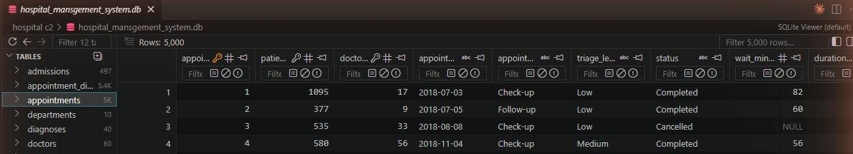 | Figure 3: patients (1,500 rows)  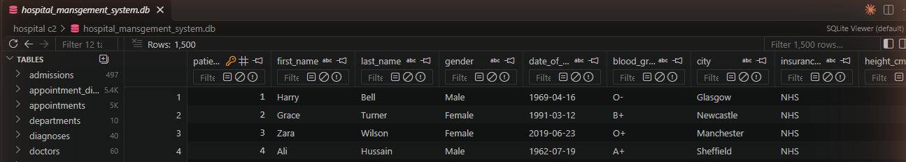
Figure 4: appointment_diagnoses (5,430 rows)  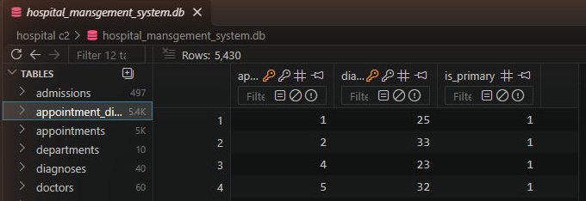 | Figure 5: prescriptions (3,936 rows)  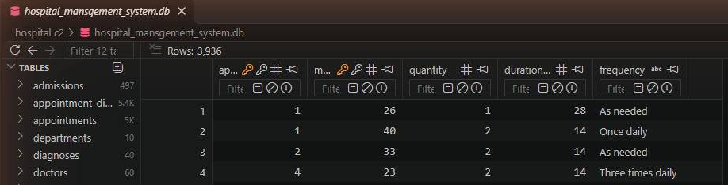
Figure 6: doctors (60 rows)  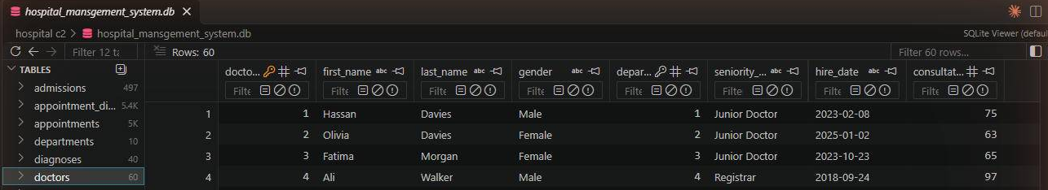 | Figure 7: admissions (497 rows)  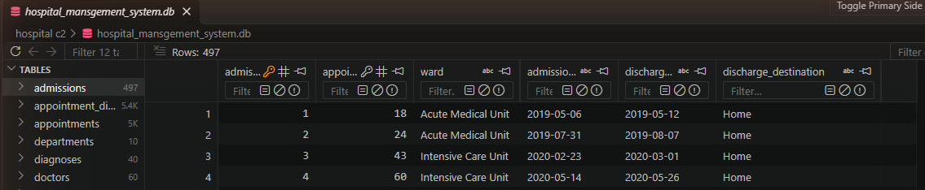
Figure 8: diagnoses (40 rows)  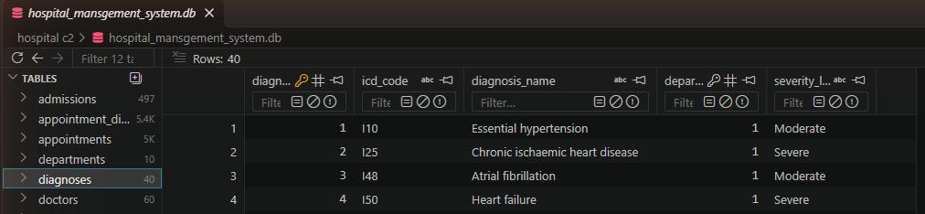 | Figure 9: medications (40 rows)  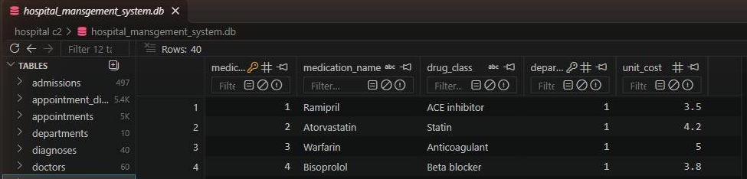
Figure 10: departments (10 rows)
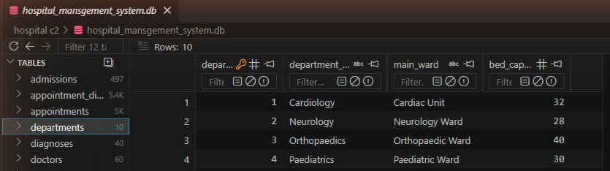
References
Codd, E.F. (1970) 'A relational model of data for large shared data banks', Communications of the ACM, 13(6), pp. 377-387.
Information Commissioner's Office (n.d.) Special category data. Available at: https://ico.org.uk/ (Accessed: 5 November 2026).
legislation.gov.uk (2018) Data Protection Act 2018. Available at: https://www.legislation.gov.uk/ukpga/2018/12/contents (Accessed: 5 November 2026).
SQLite (n.d.a) SQLite foreign key support. Available at: https://www.sqlite.org/foreignkeys.html (Accessed: 5 November 2026).
SQLite (n.d.b) Built-in scalar SQL functions: random(). Available at: https://www.sqlite.org/lang_corefunc.html (Accessed: 5 November 2026).
Stevens, S.S. (1946) 'On the theory of scales of measurement', Science, 103(2684), pp. 677-680.

